**STUDENT NAME**

**Uzma Ejaz**

**Problem Statement:**

**Required to perform the following tasks.**

**1. Create a PHP file with the name pratice.php**

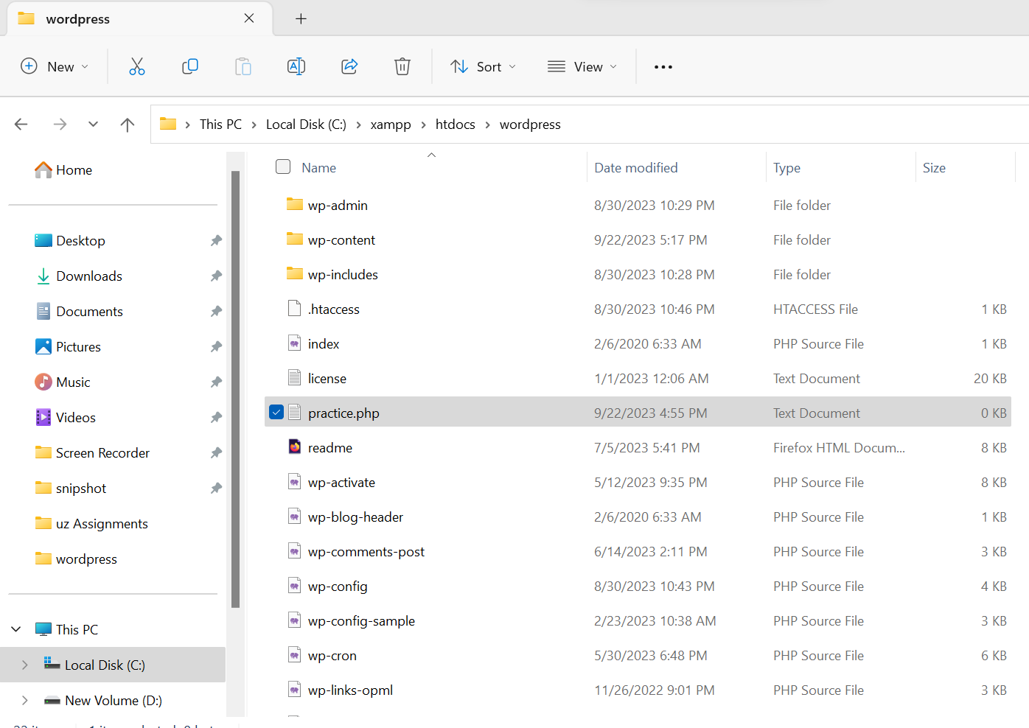

**2. Open pratice.php file and declare an array named $items and initialize the array with miscellaneous  
items: for instance, ("Pen", "Notebook", "Phone", "Glasses", "Wallet", "Car") etc.**

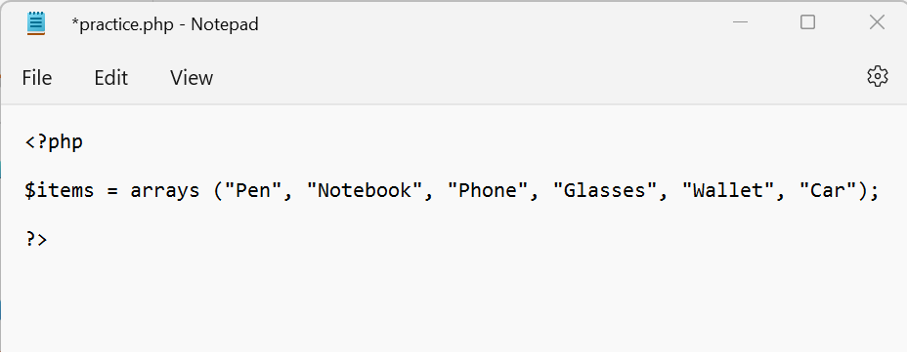

**3. Use PHP built-in count() function to display number of elements in the array**

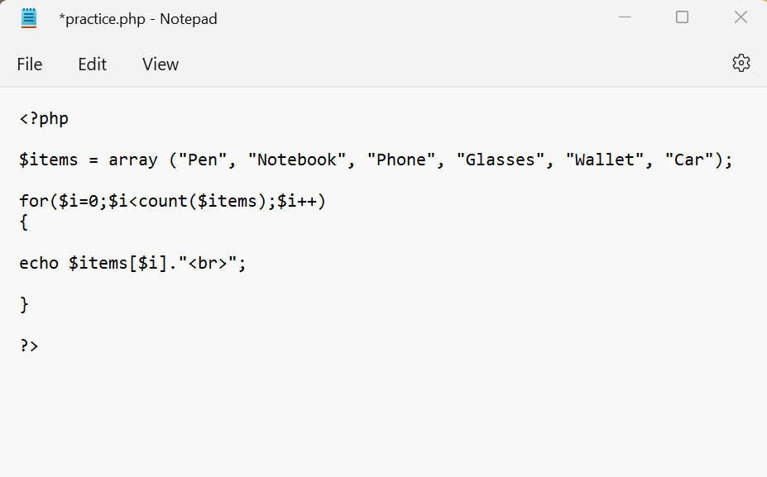

**4. Use a for loop to iterate through the array and display each element on a new line using the echo statement.**

